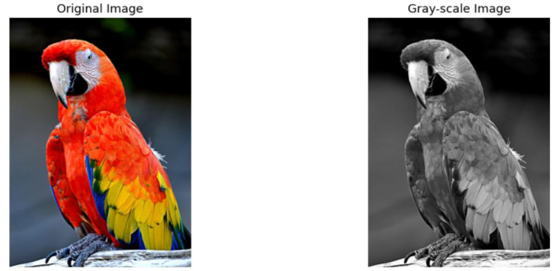
LAB EXPERIMENTS
1. Convert Image into Gray-Scale
Aim:
To read an image using Python and convert the image into gray-scale.
Algorithm:
1.Import OpenCV and required libraries.
2.Read the input image.
3.Convert the BGR image to grayscale using cv2.cvtColor().
4.Display the original and grayscale images.
5.Print the result.
Python Code:
import cv2
from google.colab.patches import cv2_imshow
from google.colab import files
uploaded = files.upload()
filename = next(iter(uploaded))
img = cv2.imread(filename)
gray = cv2.cvtColor(img, cv2.COLOR_BGR2GRAY)
cv2_imshow(img)
cv2_imshow(gray)
print("Output: Image successfully converted into grayscale.")
Output:
Result:
Image successfully converted into grayscale.

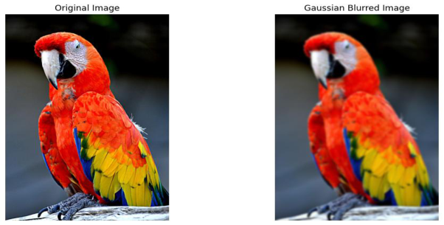
2. Gaussian Blur
Aim:
To read an image using Python and convert the image into a blurred image using Gaussian Blur.
Algorithm:
1.Import OpenCV.
2.Read the input image.
3.Apply Gaussian Blur using cv2.GaussianBlur().
4.Display the original and blurred images.
5.Print the result.
Python Code:
import cv2
from google.colab.patches import cv2_imshow
from google.colab import files
uploaded = files.upload()
filename = next(iter(uploaded))
img = cv2.imread(filename)
blur = cv2.GaussianBlur(img, (5, 5), 0)
cv2_imshow(img)
cv2_imshow(blur)
print("Output: Gaussian blur applied successfully.")
Output
Result:
Gaussian blur applied successfully.

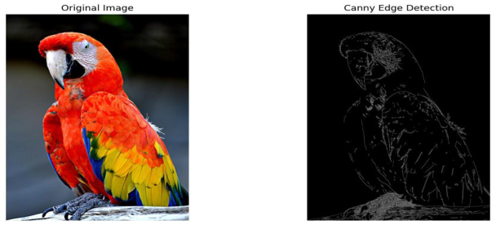
3. Display Image Outline Using Canny
Aim:
To detect and display the outline/edges of an image using the Canny edge detection function.
Algorithm:
1.Import OpenCV.
2.Read the input image.
3.Convert the image into grayscale.
4.Apply Canny edge detection.
5.Display the detected edges.
6.Print the result.
Python Code:
import cv2
from google.colab.patches import cv2_imshow
from google.colab import files
uploaded = files.upload()
filename = next(iter(uploaded))
img = cv2.imread(filename)
gray = cv2.cvtColor(img, cv2.COLOR_BGR2GRAY)
edges = cv2.Canny(gray, 100, 200)
cv2_imshow(img)
print("Output: Image outline detected successfully using Canny”)
Output
Result:
Image outline detected successfully using Canny.

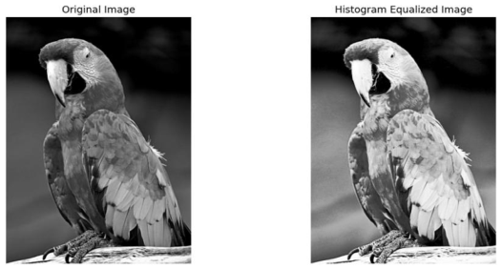
4. Histogram Equalization
Aim:
To implement histogram equalization on a given image and compare it with the original image using
OpenCV.
Algorithm:
1.Read the input image.
2.Convert the image into grayscale.
3.Apply histogram equalization using cv2.equalizeHist().
4.Display the original and equalized images.
5.Print the result.
Python Code:
import cv2
from google.colab.patches import cv2_imshow
from google.colab import files
uploaded = files.upload()
filename = next(iter(uploaded)
img = cv2.imread(filename)
gray = cv2.cvtColor(img, cv2.COLOR_BGR2GRAY)
equalized = cv2.equalizeHist(gray)
cv2_imshow(equalized)
print("Output: Histogram equalization completed successfully.")
Output
Result:
Histogram equalization completed successfully.

5. Analyze Histogram Based on Color Levels
Aim:
To write a Python function to analyze the histogram of an input image based on color levels using OpenCV.
Algorithm:
1.Read the input color image.
2.Separate the Blue, Green, and Red channels.
3.Calculate the histogram of each channel using cv2.calcHist().
4.Display the histograms.
5.Print the result.
Python Code:
import cv2
import matplotlib.pyplot as plt
from google.colab import files
uploaded = files.upload()
filename = next(iter(uploaded))
img = cv2.imread(filename)
def analyze_histogram(image):
colors = ('b', 'g', 'r'
for i, color in enumerate(colors):
hist = cv2.calcHist([image], [i], None, [256], [0, 256])
plt.plot(hist, color=color)
plt.title("Color Histogram")
plt.xlabel("Color Level")
plt.ylabel("Frequency")
plt.plot(hist, color=color)
plt.xlim([0, 256])
analyze_histogram(img)
print("Output: Color-level histogram analyzed successfully.")

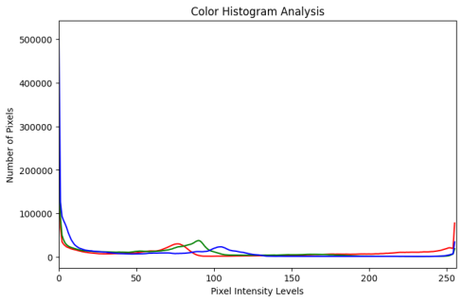
Output
Result:
Color-level histogram analyzed successfully.
6. Erosion of an Image
Aim:
To perform image erosion using the OpenCV Erode() function.
Algorithm:
1.Read the input image.
2.Create a structuring kernel.
3.Apply erosion using cv2.erode().
4.Display the original and eroded images.
5.Print the result.
Python Code:
import cv2
from google.colab.patches import cv2_imshow
from google.colab import files
import numpy as n
uploaded = files.upload()
filename = next(iter(uploaded))
img = cv2.imread(filename)
kernel = np.ones((5, 5), np.uint8)
eroded = cv2.erode(img, kernel, iterations=1)
cv2_imshow(eroded)
print("Output: Image erosion completed successfully.")

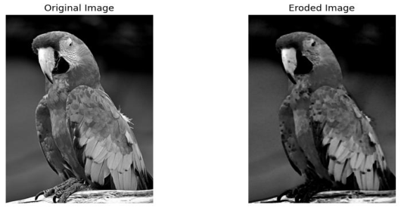
Output
Result:
Image erosion completed successfully.
7. Video Processing – Slow Motion and Fast Motion
Aim:
To perform basic video processing operations by reading a video using Python and displaying it in slow
motion and fast motion.
Algorithm:
1.Upload and read the video.
2.Open the video using cv2.VideoCapture().
3.Read video frames sequentially.
4.Display frames at different delays for slow and fast motion.
5.Release the video after processing.
Python Code:
import cv2
from google.colab import files
uploaded = files.upload()
filename = next(iter(uploaded))
cap = cv2.VideoCapture(filename)
fps = cap.get(cv2.CAP_PROP_FPS)
frame_count = int(cap.get(cv2.CAP_PROP_FRAME_COUNT))
print("Original FPS:", fps)
print("Total Frames:", frame_count)
# Slow motion: process every frame
while True:
ret, frame = cap.read()

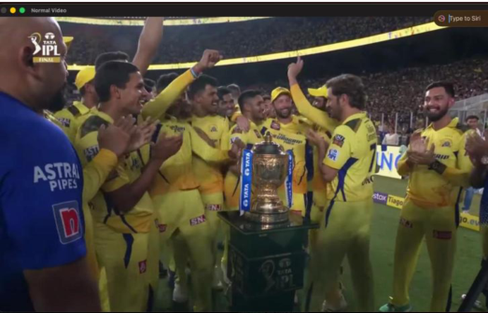
if not ret:
break
cv2.imshow("Slow Motion", frame)
if cv2.waitKey(100) & 0xFF == ord('q'):
break
cap.release()
cv2.destroyAllWindows()
print("Output: Video processed in slow motion successfully.")
For fast motion:
import cv2
cap = cv2.VideoCapture(filename)
while True:
ret, frame = cap.read()
if not ret:
break
cv2.imshow("Fast Motion", frame)
if cv2.waitKey(1) & 0xFF == ord('q'):
break
cap.release()
cv2.destroyAllWindows()
print("Output: Video processed in fast motion successfully.")
Note: cv2.imshow() may not work reliably in some Colab environments because Colab does not provide a
normal desktop GUI. For a Colab-friendly video version, the video can instead be processed and saved
with a changed FPS.
Output

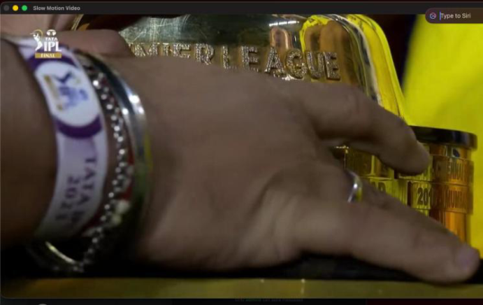
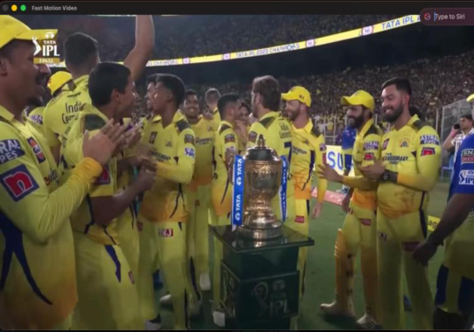
Result:
Video processed successfully in slow motion and fast motion.
8. Dilation of an Image
Aim:
To perform image dilation using the OpenCV Dilate() function.
Algorithm:
1.Read the input image.
2.Create a structuring kernel.
3.Apply dilation using cv2.dilate().
4.Display the original and dilated images.
5.Print the result.
Python Code:
import cv2
import numpy as np
from google.colab.patches import cv2_imshow
from google.colab import files

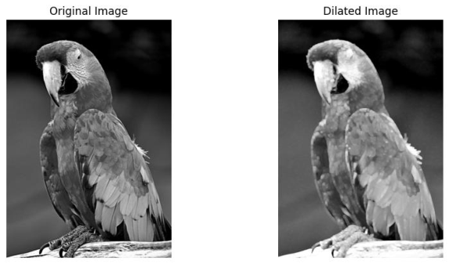
uploaded = files.upload()
filename = next(iter(uploaded))
img = cv2.imread(filename)
kernel = np.ones((5, 5), np.uint8)
dilated = cv2.dilate(img, kernel, iterations=1)
cv2_imshow(img)
cv2_imshow(dilated)
print("Output: Image dilation completed successfully.")
Output
Result:
Image dilation completed successfully.
9. Image Scaling – Bigger and Smaller
Aim:
To implement image scaling techniques to resize an image into bigger and smaller sizes.
Algorithm:
1.Read the input image.
2.Obtain the original image dimensions.
3.Increase the dimensions to create a bigger image.
4.Decrease the dimensions to create a smaller image.
5.Display all images.
6.Print the result.

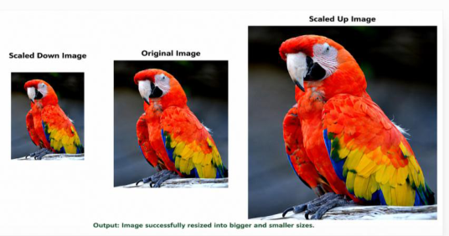
Python Code:
import cv2
from google.colab.patches import cv2_imshow
from google.colab import files
uploaded = files.upload()
filename = next(iter(uploaded))
img = cv2.imread(filename)
bigger = cv2.resize(img, (width * 2, height * 2))
smaller = cv2.resize(img, (width // 2, height // 2))
cv2_imshow(img)
cv2_imshow(bigger)
cv2_imshow(smaller)
print("Output: Image successfully resized into bigger and smaller sizes.")
Output
Result:
Image successfully resized into bigger and smaller sizes.
10. 90-Degree Clockwise Rotation
Aim:
To perform a 90-degree clockwise rotation of the given image.
Algorithm:
1.Read the input image.
2.Use cv2.rotate().
3.Select ROTATE_90_CLOCKWISE.
4.Display the rotated image.
5.Print the result.

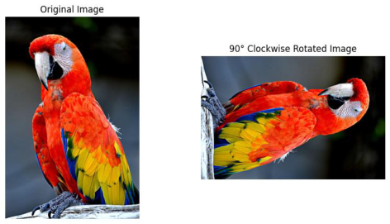
Python Code:
import cv2
from google.colab.patches import cv2_imshow
from google.colab import files
uploaded = files.upload()
filename = next(iter(uploaded))
img = cv2.imread(filename)
rotated_90 = cv2.rotate(img, cv2.ROTATE_90_CLOCKWISE)
cv2_imshow(img)
cv2_imshow(rotated_90)
print("Output: Image rotated 90 degrees clockwise successfully.")
Output
Result:
Image rotated 90 degrees clockwise successfully.
11. 180-Degree Clockwise Rotation
Aim:
To perform a 180-degree clockwise rotation of the given image.
Algorithm:
1.Read the input image.
2.Use cv2.rotate().
3.Select ROTATE_180.
4.Display the rotated image.
5.Print the result.

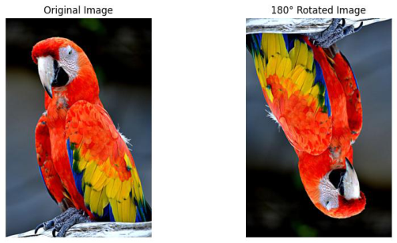
Python Code:
import cv2
from google.colab.patches import cv2_imshow
from google.colab import files
uploaded = files.upload()
filename = next(iter(uploaded))
img = cv2.imread(filename)
rotated_180 = cv2.rotate(img, cv2.ROTATE_180)
cv2_imshow(img)
cv2_imshow(rotated_180)
print("Output: Image rotated 180 degrees clockwise successfully.")
Output
Result:
Image rotated 180 degrees clockwise successfully.
12. 270-Degree Clockwise Rotation
Aim:
To perform a 270-degree clockwise rotation of the given image.
Algorithm:
1.Read the input image.
2.Use cv2.rotate().
3.Select ROTATE_90_COUNTERCLOCKWISE, which is equivalent to 270° clockwise.
4.Display the rotated image.
5.Print the result.

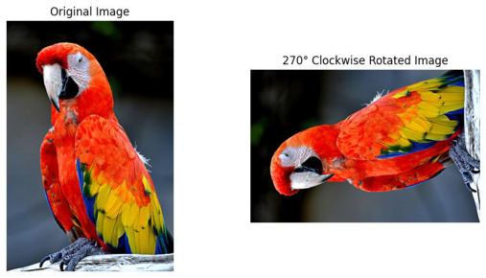
Python Code:
import cv2
from google.colab.patches import cv2_imshow
from google.colab import file
uploaded = files.upload()
filename = next(iter(uploaded))
img = cv2.imread(filename)
rotated_270 = cv2.rotate(img, cv2.ROTATE_90_COUNTERCLOCKWISE)
cv2_imshow(img)
cv2_imshow(rotated_270)
print("Output: Image rotated 270 degrees clockwise successfully.")
Output
Result:
Image rotated 270 degrees clockwise successfully.

